Discussion Artifact: Visual Media

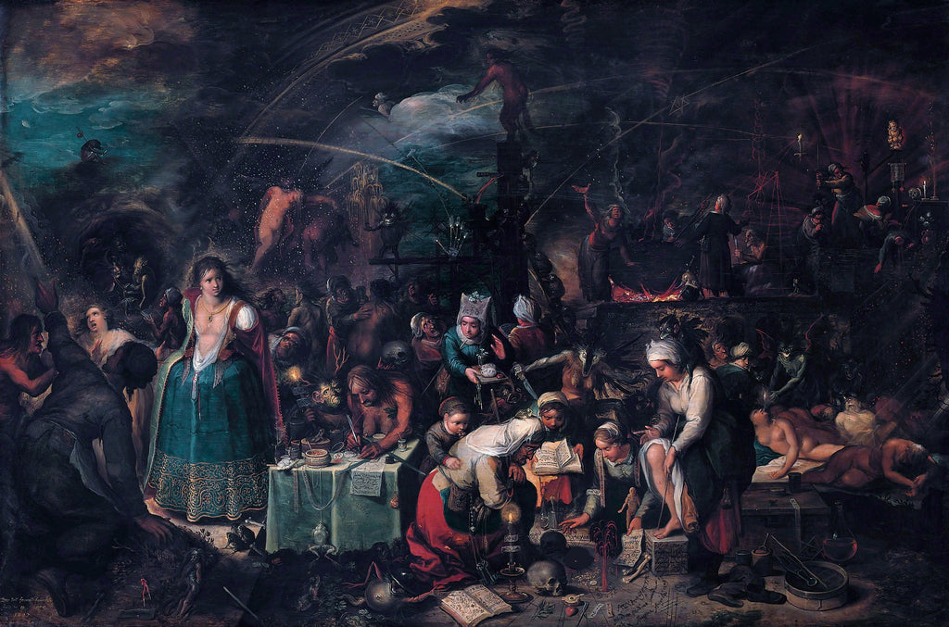

*The Witches’ Sabbath* by Frans Francken the Younger, 1649.

Discussion Artifact: Literature

“The Hag”

Robert Herrick, 1591-1674

The Hag is astride,

This night for to ride;

The Devill and shee together:

Through thick, and through thin,

Now out, and then in,

Though ne'r so foule be the weather.

A Thorn or a Burr

She takes for a Spurre:

With a lash of a Bramble she rides now,

Through Brakes and through Bryars,

O're Ditches, and Mires,

She followes the Spirit that guides now.

No Beast, for his food,

Dares now range the wood;

But husht in his laire he lies lurking:

While mischiefs, by these,

On Land and on Seas,

At noone of Night are working,

The storme will arise,

And trouble the skies;

This night, and more for the wonder,

The ghost from the Tomb

Affrighted shall come,

Cal'd out by the clap of the Thunder.

Discussion Artifact: Current Event

**Sixty-eighth Session,**

**2nd Meeting* (AM)**

**WOM/2231**

**11 March 2024**

**‘Patriarchy Is Regaining Ground’, Secretary-General Warns, while Women’s, Girls’ Rights Face Unprecedented Threat, as Commission Opens 2024 Session**

With hard-won progress in the rights of women and girls under unprecedented threat, and sexual violence in conflict rising around the world, speakers warned the Commission on the Status of Women that even in 2024, “poverty has a female face”, as it opened its annual session today.

The sixty-eighth session of the Commission meets today through 22 March under the priority theme:  “Accelerating the achievement of gender equality and the empowerment of all women and girls by addressing poverty and strengthening institutions and financing with a gender perspective”.  The United Nations largest annual gathering on gender equality and women’s empowerment brings together representatives of Member States, United Nations entities and civil society and non-governmental organizations from across the globe.

In his opening remarks, United Nations Secretary-General António Guterres stressed:  “Patriarchy is far from vanquished; it is regaining ground”.  Women and girls are also facing a war on their fundamental rights at home and in their communities.  Autocrats and populists are promoting what they call “traditional values” to attack women’s sexual and reproductive rights.  “We cannot accept a world in which grandmothers fear their granddaughters will enjoy fewer rights than they had,” he said, also noting that these power relations are being replicated in digital technologies.  When technological systems are designed by men, they result in biased algorithms that ignore women’s needs and women’s bodies.

Observing that women’s rights organizations are overwhelmingly responsible for progress on gender equality, he emphasized that in Afghanistan, the Taliban has issued more than 50 edicts suppressing women's and girls’ rights.  In Sudan, scores of women have reportedly been subjected to rape.  Noting the horrific accounts in Special Representative Pramila Patten’s report on sexual violence during the Hamas attacks, he also pointed to harrowing reports of sexual violence against Palestinian women in the Occupied Palestinian Territory.

Globally, he emphasized, poverty has a female face.  Women’s invisible domestic labour subsidizes the entire economy even as women have less access to land, natural resources and other financial assets.  Calling for a Sustainable Development Goals (SDG) Stimulus that would provide $500 billion annually in affordable long-term finance for developing countries, he noted that more than 80 per cent of finance ministers are men.  Stressing that overwhelmingly male-dominated financial institutions need to dismantle the structural barriers that are blocking women from leadership roles, he highlighted the Organization’s efforts to achieve gender parity within itself.

In a similar vein, Antonio Manuel Revilla Lagdameo (Philippines), Chair of the Commission, warned that more than 400 million women and girls, currently living in extreme poverty, are being denied the fundamental right to a life of safety, dignity and prosperity.  If the present trends persist, it is projected that by 2030, approximately 8 per cent of women globally will continue to subsist on less than $2.15 per day.  “It is our shared responsibility to eradicate women’s and girls’ poverty,” he stated, and address barriers — including the ability of financial systems and institutions to provide sufficient funding and capacities so that their poverty is recognized, understood and effectively addressed.

In addition to considering its timely priority theme, the Commission will also evaluate progress in implementing the agreed conclusions from its sixty-third session on “Social protection systems, access to public services and sustainable infrastructure for gender equality and the empowerment of women and girls”.  It will further consider an emerging issue:  “Artificial intelligence to advance gender equality:  challenges and opportunities”.

Achieving gender equality, poverty eradication and inclusive growth requires adequate fiscal space, with efficient and accountable public financial institutions using a gender lens on how they allocate resources.  He welcomed the engagement of various private sector entities in the session.  Women and girls across the world are looking up to the Commission for concrete action-oriented policy recommendations and commitments, he affirmed, calling on it to echo the call of the Beijing Declaration and Platform for Action that women’s rights are human rights.

Dennis Francis (Trinidad and Tobago), President of the General Assembly, stressed that “we are woefully lagging in our efforts to achieve the Sustainable Development Goals” — with 1 in every 10 women living in extreme poverty.  If this continues, over 340 million women and girls will still languish in extreme poverty by 2030.  Reversing this undesirable trajectory requires equal access to land, health care, education and the labour market; gender-responsive social protection policies; and measures to end discrimination impeding women’s leadership and equal participation in decision-making in all spheres.

Achieving real gender equality in critical sectors requires an estimated $6.4 trillion annually in 48 developing countries — accounting for nearly 70 per cent of the developing world’s population.  He expressed deep concern over reports of sexual abuse targeting women and girls in Palestine, Ukraine, Haiti and other places in the world, including the Reports of the UN’s Special Representative on Sexual Violence in Conflict — which indicated that there is credible evidence of rape and sexualized torture committed against women and girls by Hamas during and subsequent to the 7 October attacks, with “reasonable grounds” to believe that such abuses are still ongoing.

Stressing that meaningful progress on gender equality requires involving men in discussions on gender issues, he encouraged delegations to include more male representatives in future sessions of the Commission.  He looked forward to the adoption of a concise, action-oriented and implementable agreed conclusion.  Citing the upcoming Summit of the Future, Global Digital Compact and the Declaration on Future Generations, he urged participants to “seize these key impending opportunities to keep gender equality at the forefront of our vision for a prosperous shared future.”

For his part, Ivan Šimonović (Croatia), Vice-President of the Economic and Social Council, highlighted that if current trends persist, 342 million women and girls will be living on less than $2.15 a day by 2030.  The international community must safeguard sexual and reproductive health rights while addressing economic disparities and strengthening political and legal representation.  It is also crucial to reduce institutional barriers and expand women’s participation in leadership and decision-making while scaling up investment — bringing all stakeholders, including civil society, to the table.  Underscoring the important linkages between gender equality, economic development and human rights, he said it is crucial to address gaps in the international financial architecture.

Achim Steiner, Administrator of the United Nations Development Programme (UNDP), noted that gender inequality and the poverty experienced by so many women and girls are not inevitable outcomes of crises, but rather a consequence of systemic failures.  “While global wealth stands at nearly $500 trillion in cash, how is it possible that over 380 million women and girls are still living in extreme poverty, living on less than $1.90 a day?”  he asked.

On average, low-income countries are likely to allocate more than twice as much funding to debt servicing as they do to social assistance.  As fiscal space shrinks and social services are cut, women’s unpaid labour should not be the “safety net” that keeps households and countries afloat — but often is. The international community should commit to restructuring the debt of developing countries as part of wider reform of the international financial architecture.  Citing biases in tax systems that discriminate against women, he noted that last month, over 180 senior policymakers from 40 countries participated in the first-ever UNDP Global Dialogue on Public Finance, Tax and Gender Equality in Istanbul.  “We have a very clear target,” he stressed:  an additional $360 billion per year needed to achieve the gender equality targets of the SDGs.

Sima Sami Bahous, Executive Director of the United Nations Entity for Gender Equality and the Empowerment of Women (UN-Women), stated:  “We can transform economies, if our professed commitments to equality are matched by our budgets, as they should be” — adding that closing gender gaps in employment could boost gross domestic product (GDP) per capita by 20 per cent across all regions.  “But time is not on our side,” she cautioned, adding that 1 in 10 women around the world live in extreme poverty.  Women spend nearly three hours more per day than men performing unpaid care and domestic work.  This work keeps economies running, she said, adding that it must be compensated.

“We can and must choose to end poverty for women and girls,” she affirmed, highlighting priorities including inclusive, equitable fiscal pacts that address redistribution, progressive taxation, well-targeted investments and increased official development assistance (ODA).  Other priorities include high quality, accessible public services and inclusive, gender-responsive social protection systems with benefits for women and girls living in poverty.  It is further crucial to invest in the care economy as a strategy for reducing women and girl’s poverty and for building more robust care and green economies.  “We cannot cling to excuses that this is too difficult, too expensive, too transgressive,” she said, reiterating that an equal, sustainable and peaceful future for all people, for every woman and every girl everywhere, is within reach.

Dorothy Estrada-Tanck, Chair of the Working Group on Discrimination Against Women and Girls, emphasized that if current trends continue, 340 million women and girls will live in extreme poverty by 2030.  Since 2020, the richest 1 per cent of the world has seized nearly two-thirds of all new wealth — almost twice as much money as the bottom 99 per cent. Poverty and inequality are not inevitable, she stressed, recalling a woman who last year told the Group:  “We are not poor, we are being impoverished.”

Turning to Afghanistan, she stressed that the oppressive regime of gender apartheid has aggravated existing conditions of acute poverty.  Women and girls in Afghanistan and in some other countries are being erased from public life; their rights to education, work, health, access to justice and freedom of movement, attire and behaviour have been severely restricted.  For too long, mainstreamapproaches to gender and poverty have focused on how to integrate women and girls more effectively into existing, unequal economic systems, rather than on challenging and transforming them.  The Group recommended that States, international economic institutions and corporations take measures for the just redistribution of wealth and resources and reiterate the centrality of women’s and girls’ human rights and gender equality to poverty eradication strategies and reducing inequalities within and between nations.

Reem Alsalem, Special Rapporteur on violence against women and girls, expressed concern that the international community has failed so far to usher in a ceasefire in Gaza, which is essentially a war on women and children, or stop sexual violence against women in Sudan, the terrorization of women in Haiti, or the marginalization of women from public life in Afghanistan.  “What will it take for Member States, including those that centre gender equality in their foreign and domestic policy, to show that the lives of women indeed matter?” she asked.

Also highlighting the frightening scale at which information and technology-facilitated platforms and tools are being co-opted to facilitate sexual exploitation, violence, and abuse of women and children, she said it is vital to include violence against women and girls as a standing item on the agenda of the Commission and develop a dedicated global plan.  Her visits to different countries have shown the devastating impact of curtailing funding to grassroot women’s rights organizations that offer specialized support and outreach to those most in need.

Representing civil society, Chetna Gala Sinha, the founder of the Mann Deshi Foundation, shared lessons learned from rural women in India — ordinary women who did extraordinary things despite not having degrees.  She highlighted Kantabai, a blacksmith who lived in a drought-prone village in India, who wanted to save money.  Dismissed by a bank manager because women such as Kantabai can’t save more than half a cent a day, she applied for a banking license to start a bank for herself and similar women.  When it was denied because they couldn’t read or write, 15 of them challenged the officer at the Reserve Bank of India to an interest-calculation contest.  “Needless to say we got the banking license,” she said.  Noting that the microcredit industry in India is worth more than $60 billion, she pointed out that the rural women she works with are champions of digital banking, adding:  “never provide poor solutions to poor people — they are smart.”

Stacey Mdala (Malawi), data scientist and youth delegate, noted that many young people lack access to education because of poverty, early marriages and sex preferences.  She urged participants to support young people, protecting them from all forms of discrimination, harmful cultural and religious practices, and harassment — “but most importantly, we want to be heard”.  Citing women’s rights advocates and entrepreneurs in Malawi, Zimbabwe and Nigeria, she emphasized:  “This only shows that we are willing to put in the work for the future we want to see.”  As the world is being digitized with new technologies emerging by the day, she called for investment in women and girls in science, technology, engineering and math.  They must be included in all areas of development and at all levels “because we are the future, and the future is now”.

Ana Peláez Narváez, Chair of the Committee on the Elimination of Discrimination against Women, introduced its report, focusing on its recent work on women, peace and security; gender-based violence against women; and on women’s equal and inclusive representation in decision-making systems.  The Committee deplored the high toll of victims, mainly women and children, killed, wounded and displaced by the war in Gaza, the Occupied Palestinian Territory and Israel — calling for an immediate and sustained ceasefire and a lasting resolution involving leadership and decision-making of both Israeli and Palestinian women.  Meanwhile, the Task Force on Afghanistan continues to monitor violations of women’s human rights in that country, as the system of institutionalized violations of women’s human rights may amount to gender persecution.

The Committee co-chaired the Platform of Independent Expert Mechanisms on the Elimination of Discrimination and Violence against Women, releasing on 8 March a joint statement titled “Awareness and action:  Poverty, inequality, and gender-based violence against women”.  She voiced regret that the meeting time of the Committee’s Working Group on Communications has been reduced from 10 to 7 days this year, also expressing concern felt by the Chairs of Treaty Bodies over financial cuts — a shortfall that endangers human rights.

In other business, the Commission elected, by acclamation, Yoka Brandt (Netherlands) and Dúnia Pires do Canto (Cabo Verde) as Vice-Chairs of its sixty-eighth and sixty-ninth sessions, and María Florencia González (Argentina) as Vice-Chair of its sixty-eighth session, with Ms. Pires do Canto appointed as Rapporteur.  The Commission further appointed Saudi Arabia to serve on the Working Group on Communications on the Status of Women at the Commission’s sixty-eighth session, and Spain and Ukraine to serve on the Working Group at the sixty-eighth and sixty-ninth sessions.

The Commission then proceeded to adopt its provisional agenda (document [E/CN.6/2024/1](https://undocs.org/E/CN.6/2024/1)) and approved the draft organization of work (document [E/CN.6/2024/1/Addendum 1](https://undocs.org/E/CN.6/2024/1/Addendum%201)) on the understanding that further adjustments may be made as warranted, as well as adopting two oral decisions on procedure.